**LIBRARY MANAGEMENT SYSTEM**

**DATABASE DESIGN**

1. **Entity-Relationship Diagram (ERD):**

### ****Entities & Relationships****

* USERS stores all registered users (students, admin, staff).
* BOOKS stores details about books in the library.
* STUDENTS keeps track of students and the books they have borrowed.
* A **student** can borrow multiple **books**, so STUDENTS table keeps book and author details.

**Relationships:**

* **One-to-Many** between USERS and STUDENTS (Each student is a user).
* **One-to-Many** between BOOKS and STUDENTS (A book can be borrowed multiple times).

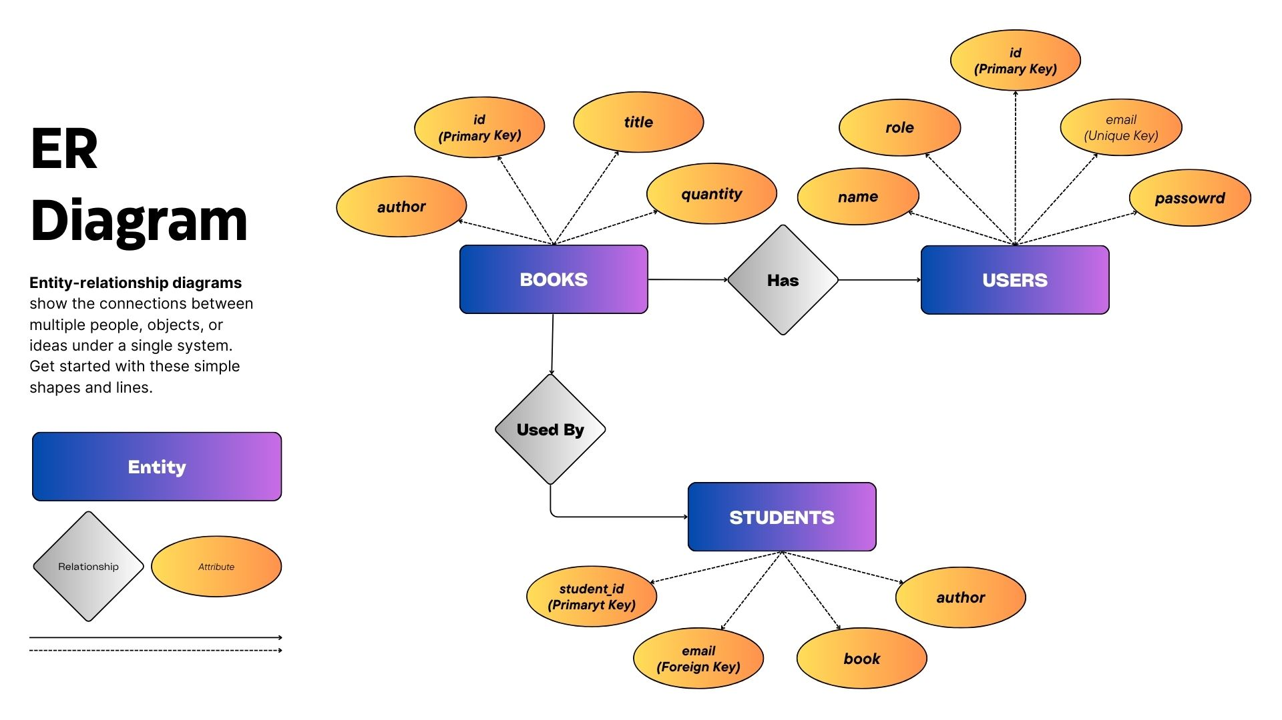

## ****SQL Schema for Database Tables:****

Here’s the **SQL script** to create the database structure in **Oracle**:

-- USERS Table

CREATE TABLE users (

id NUMBER PRIMARY KEY,

name VARCHAR2(100) NOT NULL,

email VARCHAR2(100) NOT NULL UNIQUE,

password VARCHAR2(255) NOT NULL,

role VARCHAR2(20) DEFAULT 'user' CHECK (role IN ('admin', 'user'))

);

-- BOOKS Table

CREATE TABLE books (

id NUMBER PRIMARY KEY,

title VARCHAR2(255) NOT NULL,

author VARCHAR2(255) NOT NULL,

quantity NUMBER NOT NULL

);

-- STUDENTS Table (Tracks books borrowed by students)

CREATE TABLE students (

student_id NUMBER PRIMARY KEY,

name VARCHAR2(100) NOT NULL,

email VARCHAR2(100) NOT NULL,

book VARCHAR2(255) NOT NULL,

author VARCHAR2(255) NOT NULL,

CONSTRAINT fk_students_user FOREIGN KEY (email) REFERENCES users(email) ON DELETE CASCADE,

CONSTRAINT fk_students_book FOREIGN KEY (book) REFERENCES books(title) ON DELETE CASCADE

);

## ****3. Explanation of Design:****

* **users table:** Stores users, their login credentials, and role (admin or user).
* **books table:** Contains book details with **quantity tracking**.
* **students table:** Records books borrowed by students, referencing **both users and books**.

### ****Improvements & Best Practices****

**Foreign Key Constraints:**

* students.email references users.email (Ensures the borrower is a registered user).
* students.book references books.title (Ensures only available books can be borrowed).

**Cascade on Delete:**

* If a **user** is deleted, their borrowing history (students table) is also deleted.
* If a **book** is deleted, related borrow records are also removed.

1. **Database Diagram Representation:**

